Abstract
The Sales Funnel Drop-Off Analysis Dashboard is developed to analyze customer behavior and identify where customers leave the sales funnel before completing a purchase. Using PostgreSQL for data analysis and Power BI for visualization, the dashboard tracks key metrics such as visitors, orders, revenue, conversion rate, cart abandonment, payment performance, and A/B test results. The project provides meaningful insights and recommendations to improve customer conversions, reduce drop-offs, and support data-driven business decisions.
Objective
The objective of this project is to analyze customer behavior across the sales funnel, identify drop-off stages, and measure key metrics such as conversion rate, cart abandonment, payment performance, and revenue trends. The dashboard provides insights that help improve customer conversions, optimize the sales process, and support better business decisions.
Problem Statement
Many customers visit an e-commerce website, but not all of them complete a purchase. Businesses often struggle to identify the stages where customers leave the sales funnel, resulting in lost sales and reduced revenue. Without proper analysis of customer behavior, traffic sources, cart abandonment, payment performance, and conversion rates, it becomes difficult to improve the customer journey. This project aims to analyze the sales funnel using SQL and Power BI to identify drop-off points, measure key performance metrics, and provide actionable insights that help increase conversions and improve overall business performance.
Proposed System
The proposed system uses PostgreSQL and Power BI to analyze customer activities across the sales funnel and provide interactive dashboards for business insights. It tracks key metrics such as visitors, orders, revenue, conversion rate, cart abandonment, payment status, and A/B test performance. The system helps identify customer drop-off points, monitor business performance, and generate actionable recommendations to improve conversions, reduce cart abandonment, and support data-driven decision-making.
Advantages
The proposed system provides a clear view of customer behavior across the sales funnel and helps identify where customers drop off before making a purchase. It enables businesses to monitor key performance metrics such as conversion rate, cart abandonment, payment success, and revenue through interactive dashboards. The system supports data-driven decision-making, improves customer experience, increases conversion rates, and helps optimize overall business performance.
Existing System
The existing system consists of modules for customer management, product management, customer activity tracking, cart management, order processing, and payment management. These modules record customer interactions and transactions but do not provide detailed analysis of customer behavior across the sales funnel. As a result, businesses find it difficult to identify customer drop-off points, measure conversion rates, evaluate A/B test performance, or monitor key business metrics through interactive visualizations. Consequently, decision-making is based on limited information rather than data-driven insights.
Modules Used
- Dataset: ChatGPT (Synthetic E-commerce Dataset)
- Tables: Customer, Products, Customer Activity, Cart, Orders, A/B Test
- Columns: Customer ID, Customer Type, Product Category, Event Type, Traffic Source, Device Type, Cart Status, Order Date, Order Amount, Payment Status, Test Group, Version, Conversion Status
- Tools Used: PostgreSQL, Microsoft Excel 2013, Power BI Desktop
- Data Cleaning: Microsoft Excel 2013, Power Query
- Data Processing: SQL Queries, Power Query, DAX
- Analysis: PostgreSQL, Power BI
- Visualization: KPI Cards, Funnel Chart, Bar Charts, Donut Charts, Line Charts, Slicers, Interactive Dashboard
Methodology
The project follows a structured approach to analyze customer behavior across the sales funnel. First, the dataset was prepared and cleaned using Microsoft Excel and Power Query to remove errors and ensure data quality. The cleaned data was then imported into PostgreSQL, where SQL queries were used to calculate key metrics such as visitors, orders, revenue, conversion rate, cart abandonment, payment status, and A/B test performance. Finally, the processed data was connected to Power BI, where interactive dashboards, KPI cards, and visualizations were created to analyze customer behavior, identify funnel drop-off points, and generate business insights for better decision-making.

Conclusion

The Sales Funnel Drop-Off Analysis Dashboard successfully analyzes customer behavior at each stage of the sales funnel and identifies the major drop-off points affecting conversions. By monitoring key metrics such as conversion rate, cart abandonment, payment performance, revenue, and A/B test results, the dashboard provides valuable business insights through interactive visualizations. These insights help organizations make data-driven decisions, improve customer experience, optimize the sales funnel, and increase overall business performance.

Result

The developed dashboard successfully visualizes the complete sales funnel and provides clear insights into customer behavior, conversion performance, traffic sources, device usage, cart abandonment, payment status, revenue trends, and A/B test results. The analysis identified the major customer drop-off points and highlighted key business metrics through interactive visualizations, enabling businesses to make informed decisions and improve overall sales performance.

Future Improvement
In the future, the dashboard can be enhanced by integrating real-time data for live sales monitoring and predictive analytics to forecast customer behavior and conversion trends. Additional features such as customer segmentation, personalized recommendations, advanced filtering, and machine learning models can be incorporated to improve decision-making. Integration with cloud databases and automated data refresh can further increase the efficiency and scalability of the system.

Final Output

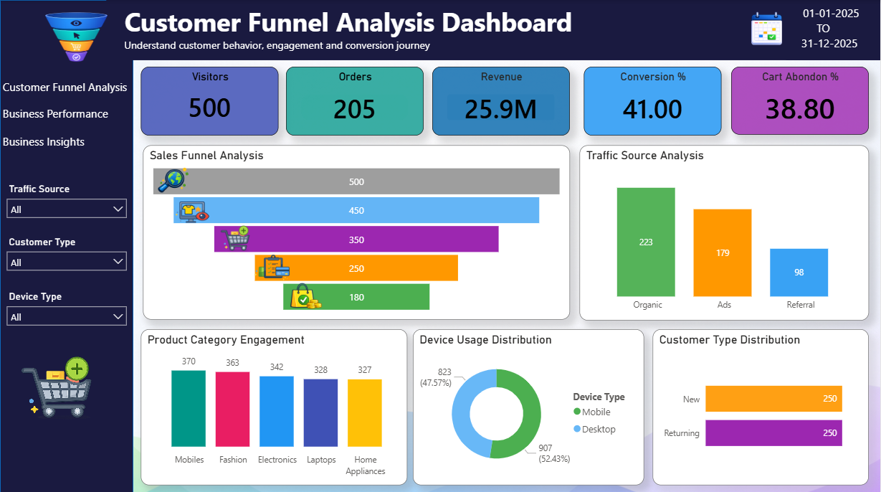

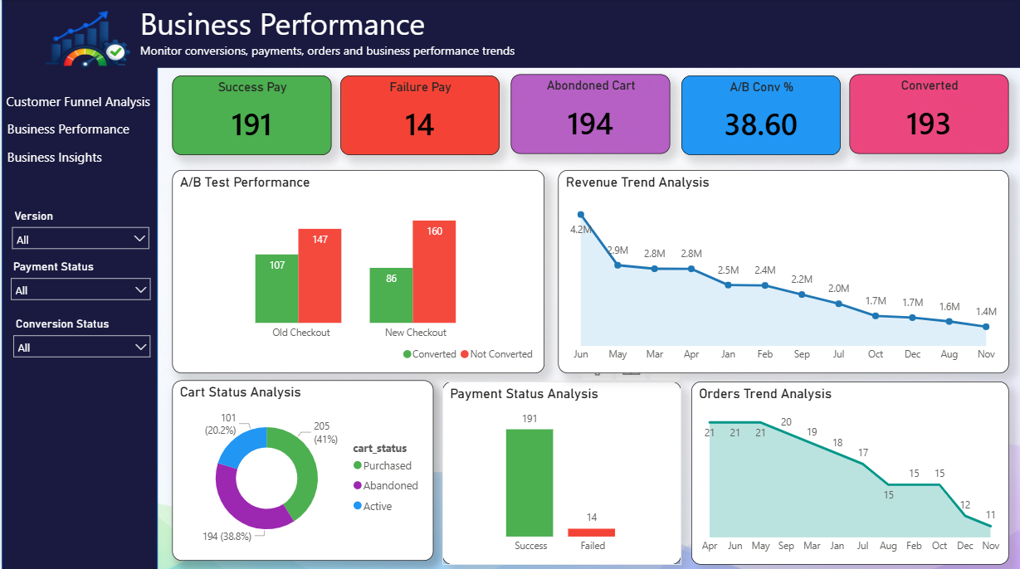

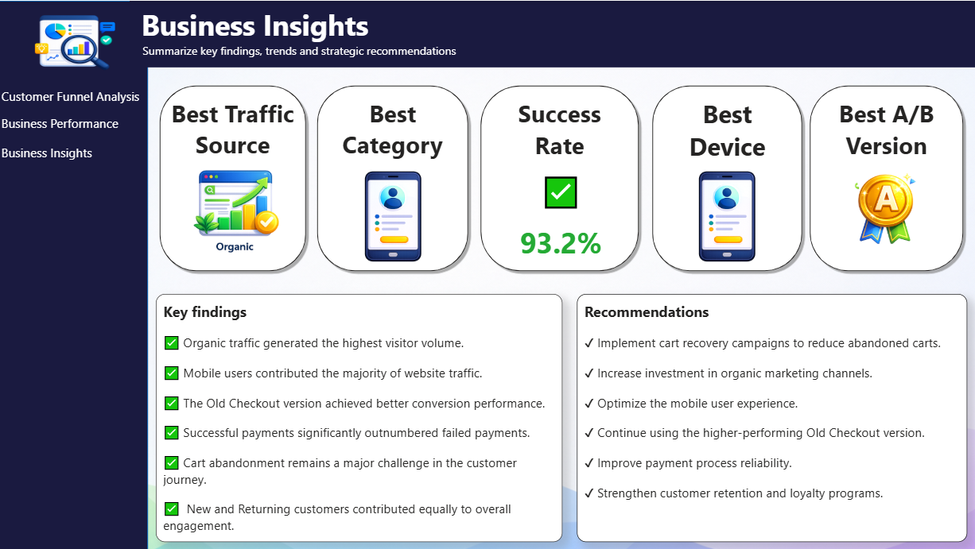

Reference
You tube channels, Google search, Chat-gpt, Co pilot

